Kirkriggs School

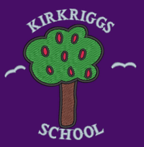

Rationale and Curriculum Design

2017-18

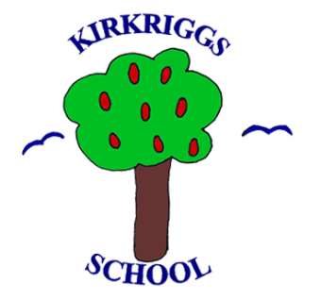
Contents
- Our School Profile

- Who are we?

- What makes us unique?

- How we have designed our Curriculum?

- How we are embedding the 7 Principles

- Our Core Curriculum

- The 4 Contexts for Learning
Who are we?

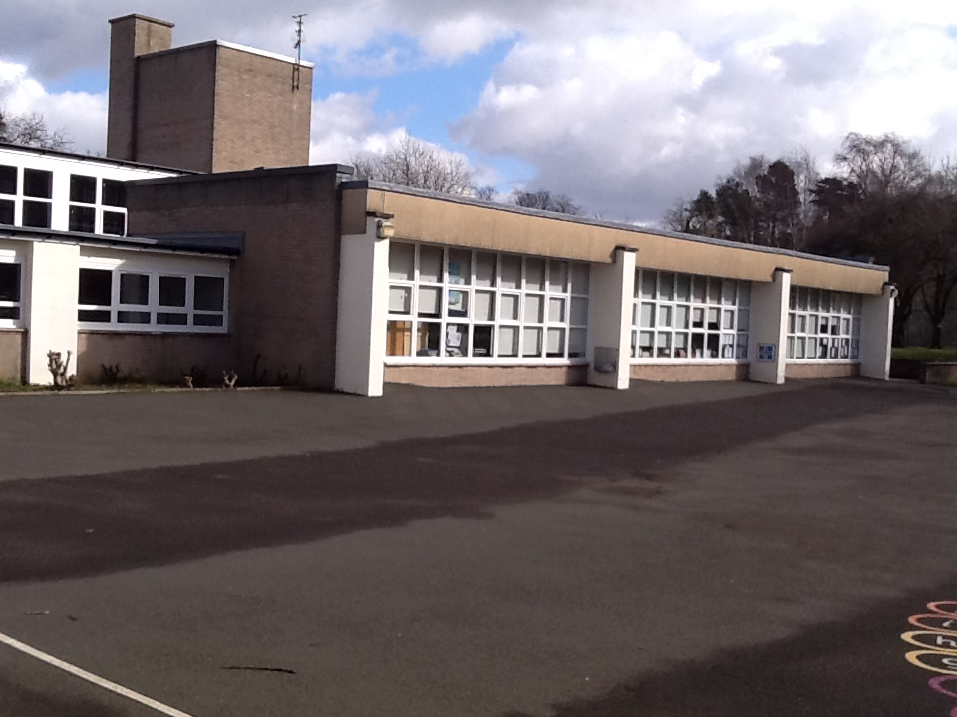

Our School Profile
Kirkriggs School is a non- denominational, co-educational school for children with additional support needs and is part of the Castlemilk Learning Community. The current role is 43 children. Our school is situated in the Castlemilk area of Glasgow and was built in 1961.
Places within the school are made by recommendation from an Educational Psychologist and or Multi Agency approval. Approximately 46% of pupils within our school are entitled to Free School Meals. Our catchment area is the south side of Glasgow and children are transported to and from the school in buses or taxis, supervised by escorts. The school has excellent links with the community and uses these to enhance the curriculum and prepare children with the skills necessary for learning, life and work.
The classes are arranged chronologically wherever possible but also take account of learner’s needs and requirements. The classes are small with a maximum of 10 children per class. Our premise consists of ten classrooms, an ICT room, Kitchen, Time-Out room, Sensory Room, Dining Hall and Gym Hall as well as well-maintained grounds and gardens which are enclosed at the back of the school, providing a safe environment for play and outdoor learning. This is also supported by an outdoor classroom in the main playground.
Our curriculum is Curriculum for Excellence and is child centred, taking account of individual needs and requirements. Our 3 core areas are Literacy, Numeracy and Health and Wellbeing. We provide many opportunities for Wider Achievement and Personal Development. We have a strong focus on children’s rights and Pupil Voice, and encourage children to express their thoughts and opinions on a variety of topics using augmentative and alternative communication systems when necessary.
Our committees include a Pupil Council, Eco Committee and Health Promoting Committee.
We value family partnership and learning and provide opportunities for parents to attend training and workshops in school. We also run a support group for parents on a weekly basis where they can drop-in to the school and meet other parents. We have also created groups via our closed Facebook group and connected parents via a text messenger service. We have a very active parent council who are fully involved in school decisions and who are an integral part of the school community, contributing to the continuous improvement of the school. We have excellent links with other agencies and business within and out with our community and use these to enhance the curriculum and provide opportunities to learn skills for life and work.

What makes us unique at Kirkriggs School?

At Kirkriggs School we believe we possess certain qualities that make us unique.

Our staff, parents and children all agree that:
- Our children are well supported in relation to safeguarding and Child Protection.
- Our families feel included.
- We take actions to remove barriers to learning.
- We involve our parents/carers in contributing and understanding their child’s learning.
- Our children are growing in confidence.
- We use the local community to enhance learning.
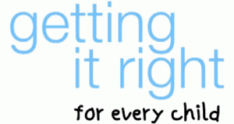
- We successfully promote and implement equality and equity.
How have we designed our curriculum?

In designing and devising our curriculum in Kirkriggs we all agreed that we should begin with our children at the centre, or the ‘heart of everything that we do’ in line with Building the Curriculum 3.

As a school community we have invested time through our session in 2017-18 in consulting all stakeholders to ensure our Vision, Values and Aims were a true representation of who we are at Kirkriggs and what we want for our learners.
Our Motto is:

‘Together we will be the best we can be!’

Our Vision in Kirkriggs is of a team working together to build a nurturing environment which all people feel safe, happy and healthy within. We aim to provide opportunities for all of our children to develop the skills and experiences they need to be the best they can in both in school and the wider community.
At Kirkriggs School we have agreed that our core Values define and shape the very essence of our curriculum. We strive daily in Kirkriggs to ensure all of our children, teachers, support staff, parents and stakeholders feel;
- Respected
- Included
While celebrating and promoting;
- Achievement
- Independence
- Equity

Our Aims are:
- To work together to provide challenging and motivating active learning experiences to ensure all children can be the best they can be.
- To take a holistic view of our children to ensure the highest standards of teaching and learning for all children to help them achieve a positive and sustained destination.

(Vision, Values & Aims Display)

Extensive consideration is also given to how best enable our children to become:
- Successful Learners
- Responsible Citizens
- Confident Individuals
- Effective Contributors

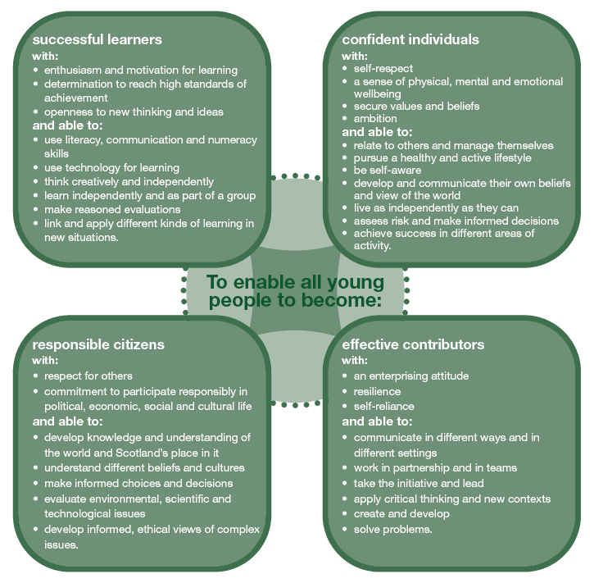

At Kirkriggs School we follow the advice and guidance supplied from Education Scotland relating to Curriculum for Excellence and curriculum design;
- Challenge and Enjoyment
- Breadth
- Progression
- Depth
- Personalisation and Choice
- Coherence
- Relevance
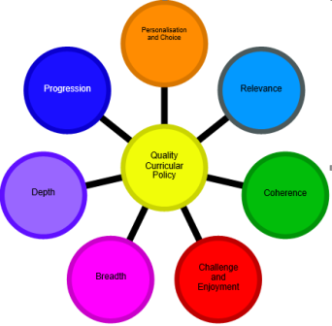

How are we embedding the 7 Principles of a Curriculum for Excellence in Kirkriggs School?
At Kirkriggs School we take all 7 principles into account as we view them as part of our core foundation in ensuring that all children in our school develops and learns to be the best they can be.
They also form the basis of evaluation and review for us as a Senior Leadership Team and Teaching Staff.
Principle | How we achieve it at Kirkriggs School
Breadth | - Breadth is achieved by designing learning activities and contexts based on all the experiences and outcomes.  - Staff plan for all pupils to have the opportunity to make progress through all experiences and outcomes.  - Pupils work through all experiences and outcomes at a pace relevant to them which ensure secure understanding and the ability to apply their learning in different contexts where appropriate.  - More time is provided to the ‘BIG 3’ areas of the curriculum.  - Pupils are provided with motivating and challenging activities at their level with real life links to ‘skills for learning, life and work.
Depth | - Pupils are given opportunities to become more secure in their learning rather than moving quickly from one topic or level to the next.  - Collaboration and Professional Dialogue between staff and pupils allows them the opportunity to add depth to learning by spending time discussing learning, explaining it to others and applying knowledge and skills in a variety of contexts.  - Staff use informed professional judgements about when pupils require further learning activities and contexts to secure learning within a level while utilising the benchmarks.
Challenge and Enjoyment | - Staff have high expectations of what pupils can achieve.  - Activities are suitably challenging, engaging and motivating. We promote high aspirations and ambitions for all!  - Tasks selected are differentiated to present an appropriate challenge.  - Resources are used and developed relevant to the pupils needs.  - Activities are encouraged to be innovative and creative.  - We celebrate all areas of success!  - Personal achievements are recognised.
Progression | - The organisation of the experiences and outcomes into levels helps to plan progression to meet the varying needs of our pupils.  - Formative assessment evidence is actively used to allow teachers to make professional judgements about pupil progress.  - Further study and engagement with the Benchmarks in each curricula area help to inform staff judgement.
Coherence | - Pupils experience a blend of programmes and studies which focus on personal achievement and learning.  - If appropriate, the local community and partners are featured to enhance teaching and learning.  - There is coherence and consistency in the development of Literacy, Numeracy and HWB encompassing skills for learning, life and work.  - Staff are encouraged to be flexible in their approach to time management.
Personalisation and Choice | - Staff use their extensive knowledge of our pupils’ prior experiences, learning and interests to provide customised support.  - Pupils have choice in a variety of activities.  - Pupils, were appropriate, are involved in the planning and assessment process.  - Pupils are encouraged to learn independently.  - Opportunities for personal achievement both within the school and outwith are celebrated.
Relevance | - The curriculum content connects with the child’s experience, learning and interests in and out of school.  - Staff use their in-depth knowledge of the whole child during teaching and learning to inform and shape contexts for learning.  - Pupils will know why, what and how their learning links to ‘skills for learning, life and work’ and how that fits with their family and local community.
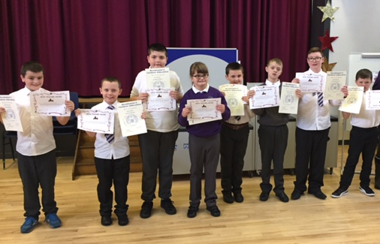

Our Core Curriculum Structure
Our Core Curriculum
When designing our curriculum we took a number of key factors into consideration. We felt key drivers in our discussions were:
‘What do we want the children of Kirkriggs to look like?’
‘What skills and capabilities to do we want the children of Kirkriggs to leave with?’
We also wanted to consider the following factors:
- Our school population
- Our local community
- What our learners and families wanted
- What interventions were required to best support our children to become Effective Contributors in the 21st Century.
Additionally, we decided that we wanted our children to have developed particular skills by the time they had completed P7:
- Core Literacy and Numeracy Skills
- Social and Communication Skills
- Resilience
- Adaptability

Based on this we made the following Key Decisions:
- We would organise our Curriculum Experiences under the 4 contexts for learning as highlighted by Education Scotland.
- Curricular Areas and Skills Development
- Interdisciplinary Learning
- Ethos and life of the school
- Opportunities for personal and Wider Achievement
- We would seek to ensure that Literacy remained our main priority as we wanted our children to have basic core skills in Literacy by P7.
- Numeracy and Health and Wellbeing would be prioritised as CORE AREAS.
- We decided to ‘bundle’ the remaining 5 curricular areas in an Interdisciplinary way.
- We wanted our learners to have opportunities to develop skills for learning, life and work as much as possible.
- We decided that we needed more baseline and formal assessments to inform professional judgement.
The 4 Contexts for Learning

Develop resilience and confidence
Experience & share achievements in and beyond class
Have their voice heard
Nurturing & Inclusive Environment
Contribute as positive role models
Action the school values
IDL Bundles

IDL Whole School Themes
Literacy
Numeracy
HWB
ICT Skills
PE Skills
Opportunities for personal and Wider Achievement
Ethos and life of the school
IDL
Interdisciplinary
Learning
Curricular
Areas and Skills
Curricular Areas and Skills Development
Our school curriculum and skills are developed through an ‘I can’ approach, across all years with the delivery of Experiences and Outcomes. The development of skills is essential to learning and supporting our pupils to become ‘Successful Learners, Confident Individuals, Responsible Citizens and Effective Contributors.’ The skills and attributes which our pupils develop will support them to be lifelong learners in their adulthood. Our curriculum aims to foster the development of key skills in communication, independence, problem-solving, critical thinking and social and personal awareness and interaction. In particular, it places key emphasis on the acquisition of Literacy and Numeracy Skills.
IDL
We believe that this approach towards delivering the curriculum brings about rich rewards, allowing for increased and improved collaboration across subject areas and leads to exciting and challenging opportunities for our pupils to make connections across learning within the context of Broad General Education. We have a whole school theme every year which is very successful vehicle for children to achieve progression in their learning and for staff to share their knowledge and moderate children’s learning.

Ethos & Life of the school
Our curriculum offers a broad range of learning experiences for our pupils, where the children and a wide range of relevant partners, contribute to planning themes and topics in order to make learning meaningful. Our children participate in the following activities within the local community –
- Linn Park
- The Jeely Play Zone
- Positive Play Outings
- Swimming
- Riding for the Disabled
- PE sessions at Greater Clyde College
- Outdoor Learning experiences
- Golden Time trips in the community
- Performing in the community

Opportunities for personal and Wider Achievements

Our pupils are encouraged to contribute to the school community at every stage, where they have opportunities to lead their own learning and they are instrumental in bringing about change and improvement through our Pupil Voice meetings and committees. Shared values are communicated and promoted through assemblies, Health and Wellbeing sessions and in our school Newsletters and HT Vlogs. Children are active in developing and supporting the work of the school. We also involve parents in the life of the school and the curriculum through the Parent Council, Parent workshops, Drop-Ins, Shared learning sessions, in-service and through our self-evaluation process.

Opportunities for personal and Wider Achievements
We endeavour to involve our children where possible in selecting evidence of their learning from what they say, make, write and do, Children work on achieving their set targets both academically and developmentally daily. Children are also encouraged to reflect on their learning and what they have done in school each day. Children also evaluate their personal learning plans with their teacher.
Wider Achievements are promoted at Assembly, on our noticeboards, BLOG, TV and via social media. We send out our Wider Achievements booklet to parents annually and ask them to send in completed forms or post and tag us to promote this success.
We have clubs in Boccia, football, gymnastics and dance currently in the school and actively attempt to promote clubs requested by our children at Pupil Voice. Children, while promoting a healthy lifestyle, also develop skills for life whilst participating in these activities.

