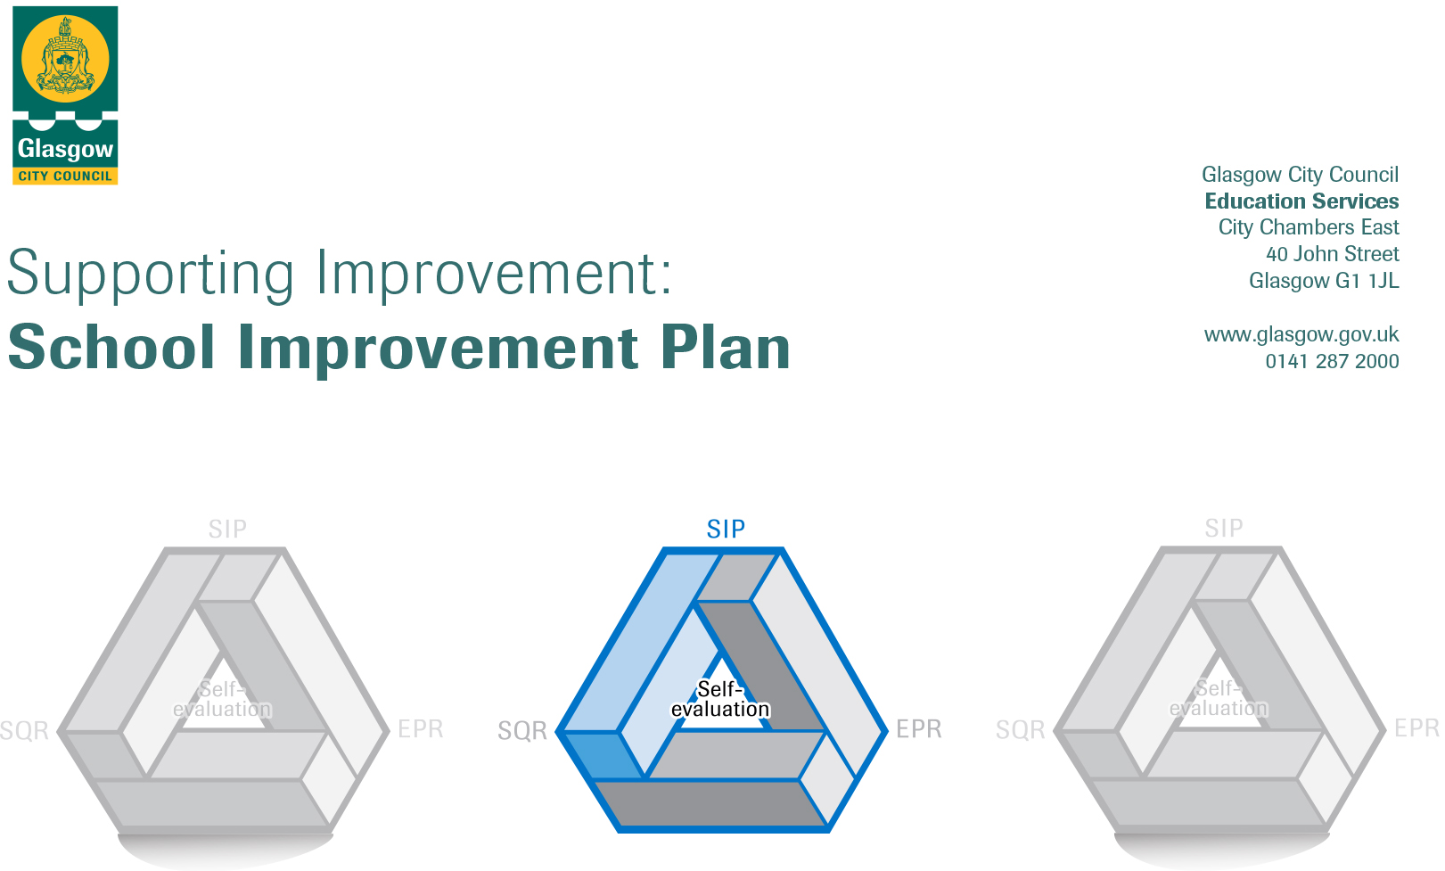

Establishment |  | Kirkriggs Primary School
Head of Establishment |  | Denise Laverty
Area/Local Improvement Group |  | LIG 3
Head of Service |  | Maureen McKenna
Area Education Officer/  Quality Improvement Officer |  | Donnie MacLeod  Sharon McGeever

CONTENTS
1. Vision, Values and Aims
2. Summary of Self-Evaluation Process / Priorities for Improvement in the current session
3. Action Planning

Action Plan Summary for Stakeholders

1. Our Vision, Values and Aims
Vision: To work together as a team to build a nurturing school environment. We provide opportunities for our children to develop skills and experiences that will prepare them for learning, life and work just now and in the future.

Core Values: Respect, Inclusion, Achievement, Independence and Equity

Aims:
- To work together as a team to provide high quality learning experiences and ensure that our children achieve their highest potential
- To meet all the needs of our children and support them to achieve a positive destination.

Motto: Together we will be the best we can be.

2. Summary of our self-evaluation process.
Opportunities were given to all stakeholders (parents, staff, children and other agencies) to express their thoughts and views throughout the year. These occurred both in a formal and informal manner throughout the school session and information was collected in a variety of ways including dialogue, learning conversations and questionnaires. Termly questionnaires were given to all stakeholders.

Self-evaluation questionnaires are given out to parents termly and offers a variety of methods for completion: school app, hard copy, school website and with a member of the SLT at parent’s night or at another arranged time.

Self-evaluation questionnaires for teachers are built into the working time agreement termly and responses can be completed online or by hard copy.

SFLWs are given time to complete questionnaires termly during the school day and can complete a hard copy or online version.

Pupil self-evaluation was on going throughout the year at weekly pupil voice meetings and hard copy feedback was gathered.

August 2018: Whole staff analysis of self-evaluation results and moderation of questions and evidence to support answers

CAT sessions for teachers April to June 2019: Self-evaluation using the challenge questions for 2.5 Family Learning and 2.3 Learning, Teaching and Assessment and discussion about evidence.

April 2019: Parent consultation about PEF spending (10% attendance)

May 2019: Self-evaluation of SIP and priorities for next year

Strengths identified:

Ensuring Wellbeing, equity and Inclusion (3.1)
- As a school community we are improving outcomes for families
- Most of our children can identify the SHANARRI indicators and discuss the opportunities and support that they receive in school to have their needs met.
- Relationships across the school are supportive and respectful and we work as a team to improve outcomes
- Equity is a core value and children have a range of opportunities to be involved in the life of the school.

Partnerships (2.7)
- We have positive, sustainable relationships with a variety of partners to offer a range of experiences and learning contexts for our children
- Our partnerships impact positively on attainment and the development of skills for learning, work and life.

Personalised Support (2.4)
- We have effective strategies for positive relationships and behaviour which all staff and partners take responsibility for.
- Learning targets which are aspirational and achievable are in place specific to individual learners
- Staff and partners take positive steps to removing barriers to learning and employ strategies and learning styles that support improved outcomes.
- The school, parents, relevant partners and where appropriate the children are involved in discussions and decisions about learning and support.

Priorities for development:
1: 2.3 Learning, Teaching and Assessment: To promote improvement in learning, teaching and assessment through providing appropriate pace and challenge, using assessment data effectively and streamlining paperwork and procedures.

2: 2.5 Family Learning: To improve family engagement and the range and type of family learning programmes for our families.

3
: 3.2 Raising Attainment To effectively track attainment over time and use data and assessment effectively to raise attainment in literacy and numeracy.

3. Action Planning

No. | Quality Indicator | Priority
1 | 2.3, 3.2 | To promote improvement in learning, teaching and assessment through providing appropriate pace and challenge, using assessment data effectively and designing effective planning and tracking to meet individual needs and raise attainment.

Tasks to achieve priority | Timescale  and checkpoints | Evidence of Impact > (data, observation, views)
Learner engagement: Teaching staff CPD input on the Leuven’s scale and how to use observation to assess wellbeing and involvement. Examining Ferre Laevers starter Action points to support reflection. | CAT session 1.5 hours  29th January 2020 | QA visits will show higher learner engagement. Professional dialogue with staff and children will evidence wellbeing. Dialogue between class team members based on the scale and actions will support reflection and future actions.
CPD for teaching staff on pace and challenge | 18th September 2019 CAT session 2 hours for delivery and 1 CAT session 1.5 hours for follow up. Total 3.5 hours. | QA visits will evidence appropriate pace and challenge for learners with learning well matched to their needs. Reflection from staff on current challenge and dialogue with SLT will impact on teaching and learning. Raised attainment.
Teaching staff professional dialogue and consultation on assessment in literacy and numeracy including baseline assessments and annual assessment calendar. | 1 CAT session 2 hours 28th August 2019 | The introduction of new assessments in literacy and numeracy to gather reliable data that will allow accurate reporting on progress and inform next steps in learning. Professional dialogue at tracking meetings will show evidence of the use of data. Raised attainment will be evidenced in QA visits and planning and tracking meetings. Assessment calendar will enable reliable data gathering and impact on planning.
Teaching staff CPD on BM Benchmarking | CAT session 1.5 hours  26th September 2019 | Accurate assessment to plan next steps and measure progress. Identify barriers and enable targeted support. Comparison of comprehension and reading skills. Supports teacher’s professional judgement.
CPD for teachers on Angus Numeracy assessment | CAT session 1.5 hours  9th October 2019 | Enables the use of accurate assessment to inform planning and measure progress. Allows seeing who is/isn’t on track with individual learning. Tracking meeting evidence.
CPD for staff on Big Writing criterion for writing assessment | CAT session 1.5 hours  16th October 2019 | Cold piece writing 3 times a year. Moderation of writing amongst school staff then staff from other establishment. Impact on teacher’s professional judgement. Reliable and accurate assessment. Informs planning.
Evaluation and reflection of assessment | CAT session 1.5 hours  11th December 2019 | Professional dialogue amongst teachers about practicalities of assessment, reflection on their professional judgement. Improved efficiency of tracking meetings and understanding of assessment.
Teaching staff will break down early and first benchmarks and skills to design progression planners for learner pathways. | In Service day 3 5 hours | Improved planning and tracking of the learner journey and curricular design principles. Impact on breadth of learning.
Input on self-evaluation at classroom level | 1 CAT session 2 hours  4th December 2019 | Professional dialogue with SLT and teachers about reflection conclusions. Improvement in learning and teaching due to self-evaluation process. Views of teacher on improvement.

Staff leading on this priority – including partners | Resources and staff development
All teachers, Sharon McGeever Lead Officer, Geraldine Parkinson Lead Officer, HT, Julie PT from Miller Primary, | Leuven Scale, assessment materials: Big Writing, Angus Numeracy, baseline assessment, PM Benchmarking, Benchmarks, planning and progression examples,

No. | Quality Indicator | Priority
2 | 2.5 | Family Learning: To improve family engagement and the range and type of family learning programmes for our families.

Tasks to achieve priority | Timescale  and checkpoints | Evidence of Impact > (data, observation, views)
New questionnaire to parents about type of engagement and preferred activities | September 2019 evaluate Dec 2019 | Views of parents of how they can be supported to engage with the school and to support their child’s learning. Engagement should be up at family learning activities. Views of staff and how they can contribute and support. Views of parents and child of impact on family learning. Higher response to consultations.
Questionnaire to pupils about what events and activities they want to see being run for them and their parents | September 2019  Evaluate Dec 2019 | Attendance at family learning events should be up. Children’s evaluations on enjoyment and extension to home. Staff observation on parent/child relationships and learning to inform future planned activities and individual targets.
Provide holiday family learning activities in the school | October 2019  Evaluate  February 2019 | Feedback from parents and children. Views of Jeely staff on effectiveness. Better engagement at school events. Development of parent and child play skills through observation.
Supporting reading development workshops for parents including IDL literacy (digital learning) | December 2019  2 CAT sessions (early and first)plus planning 4 hours total 8th and 22nd Jan 2020 | Parents better supporting reading at home, encouraging reading for enjoyment. Improved parental involvement in reading intervention groups twice weekly. Teacher and parent dialogue about reading productive due to increased understanding. More relevant reporting to parents.
Supporting numeracy development workshops for parents (including Sumdog (digital learning) | 2 x 1 hour CAT sessions (early and first) plus planning 4 hours total 19th and 26th February 2020 | Parents increased understanding about supporting numeracy at home through feedback/questionnaires before and after input. Increased parental understanding about the amount/type of support that their child should receive for homework. Teacher’s judgement and assessment show increased attainment.
Provide a range of classes for parents including healthy cooking | February 2019 Evaluate March 2019 | Attendance at event. Learner conversations with children about dinners. Feedback from parents. Observation of activities and identification for further support.
Provide a range of information and support sessions for parents to enable them to work in partnerships with organisations to improve family outcomes | March 2019 Evaluate April 2019 | Expanded range of partners, review meetings and parents night conversations with parents, improved health and wellbeing observed in children.

Staff leading on this priority – including partners | Resources and staff development
Family Support Worker Nicolle Mearns, Range of partnerships, All teachers, Paul MacConnell (PT), Nicola Orr (DLOL), pupil council, parent council  Jeely piece play workers, Tesco | Parent questionnaires/consultations, child friendly questionnaires, school let with janitorial cover, Jeely, piece activity plan, grant for lunches, planning session with parents, literacy games and resources, ICT suite, numeracy games and resources, I pads, timetables, children’s kitchen, event timetable.

No. | Quality Indicator | Priority
3 | 3.2 | Raising Attainment To effectively track attainment over time and use data and assessment effectively to raise attainment in literacy and numeracy.

Tasks to achieve priority | Timescale  and checkpoints | Evidence of Impact > (data, observation, views)
CPD on Moderation and assessment | 12st August 2019 CAT session 2 hours and follow up 1.5 hours. 3.5 hours total | Professional dialogue and activities will allow teachers to provide consistent application of level achievement and use evidence to support this. Consistent teacher’s judgement will combined with assessment will impact on planning and attainment and achievement.
Input for teachers and SFLWs on the Collaborative School | 11th September 2019 1 CAT session 2 hours | All staff has the same focus. Professional dialogue between teachers, SFLWs and SLT will enable staff to see through different lenses and have an increased understanding of their roles. This will impact positively on class team working to support pupils and on support for pupils to raise attainment.
Moderation sessions in house and with learning community peers | 8 hours from WTA  In-service day 7 (4 hours) and 2 CAT sessions 3 hours. 7 hours total. | Professional dialogue opportunities across the school and with mainstream and ASL peers to share the utilising of data for assessment and professional judgements about levels and achievement standards. Views of staff on their own professional judgement. Evidence of attainment through robust assessment, the use of data and accurate professional judgement.
Working party on tracking attainment over time | 3 CAT session 4.5 hours total  26/2/20, 4/3/20, 11/3/20 | Improved tracking over time will allow accurate tracking of attainment and achievement and allow predictability of future progress and accurate planning that will challenge learners. Tracking meetings will validate professional judgements and use of assessment and show improved outcomes or allow
CPD for teachers on using Data at classroom level | 13th November 2019 CAT 2 hours and CAT session development/follow up 1.5 hours. 3.5 hours total | Teachers will make better use of data to measure progress and inform next steps.
All staff input from GDSS on reading strategies | In set day 4 hours | Improved universal and targeted support for children to raise attainment. Tracking meetings will evidence this. Professional dialogue between SFLWS and teachers about supporting individual and class needs. Views of all staff on effectiveness of strategies. Impact on planning and setting targets. Learner conversations with children on effectiveness. SFLWs to lead learning and take literacy groups.

Staff leading on this priority – including partners | Resources and staff development
Head teacher, GDSS, Sharon McGeeever (Lead Office GCC), Geraldine Parker (Lead office GCC), Staff from Toryglen School, Karen Alston Head Teacher Toryglen School, DLOL Nicola Orr, all staff. | Achieving a level guide, planning and assessment folders, resources as requested by GCC deliverers.

